Device App

Version 1.0

Contents

**1. Introduction3**

1.1 Overview3

**2. Add Data4**

**3. Search Data5**

**4. Get Data in pdf format6**

# Introduction

## Overview

This document provides high level overview on the device APIs.

This portal consists for three main functionalities:

*Add Data* - Allows user to add data in database

Search Data - Allows user to get data for a specific deviceid

Get Data in pdf format - This API returns data in a pdf format

For detailed information about each section please refer below:

# Add Data

This API will let you add multiple records in the database at a time. Few things to keep in mind before using this API are:

* Content type can only be json.
* Json records must be enclosed in a list.
* There are 7 mandatory parameters with data type as string for this API.
* The parameters and sample format to post a record of data is as follows:

[

{

"deviceid": "Mumbai",

"data1": "20192",

"data2": "20213",

"data3": "20192",

"data4": "20213",

"data5": "0",

"dt_start": "Apr 21, 2022 19:35:49"

}

]

* Date format for parameter “dt­_start” should be exactly same.
* Username and password must be provided in basic auth.
* Below is an example of how to use this API

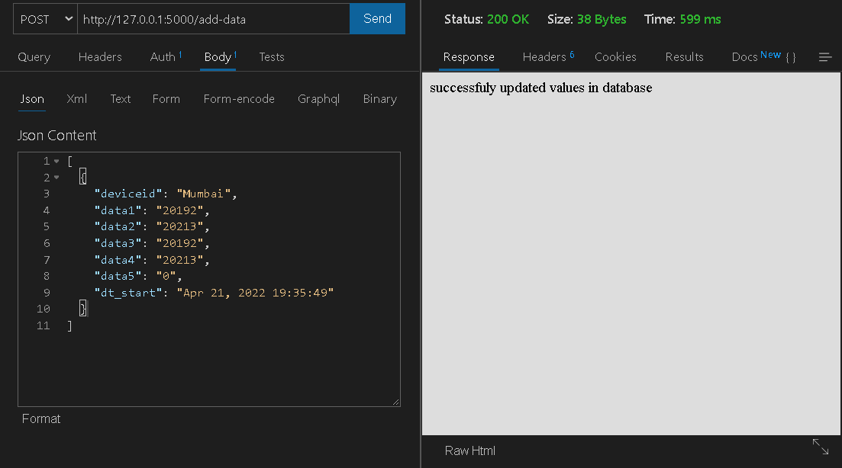

# Search Data

This API will let you search for a specific deviceid from database. . Few things to keep in mind before using this API are:

* Content type can be json or form encoded (for access of API from UI)
* There are 3 parameters with data type as string for this API : “deviceid”(mandatory), “from”(optional),”to”(optional)
* If only “deviceid” is provided query will return latest 25 records from database for that deviceid
* If only “deviceid” and “from” parameter is provided then records specific to that date will be returned from database for that deviceid
* If all 3 parameters are provided then records in range of “from” and “to” parameter will be returned from database for that deviceid
* If Content type is json then username and password must be provided in basic auth and for form encoded there will be a login page to access this API
* The sample format to pass parameters for this API is as follows:

{

"deviceid": "Canada",

"from": "2021-03-29",

"to": "2021-04-05"

}

* Date format for parameter “from” and “to” should be exactly same.
* Below is an example of how to use this API

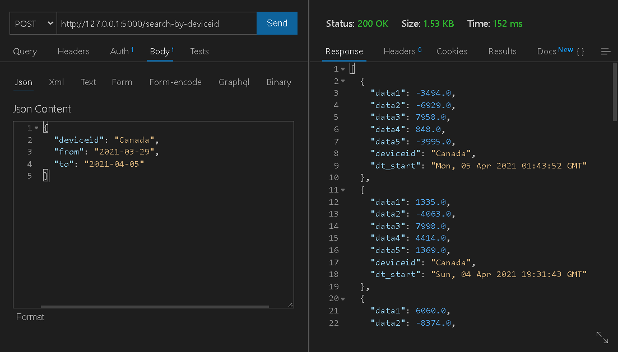

# Get Data in PDF format

This API will return pdf for a specific deviceid from database. . Few things to keep in mind before using this API are:

* Content type can be json or form encoded (for access of API from UI)
* There are 3 parameters with data type as string for this API : “deviceid”(mandatory),” from”(optional),”to”(optional)
* If only “deviceid” is provided query will return latest 25 records from database for that deviceid in a pdf format
* If only “deviceid” and “from” parameter is provided then records specific to that date will be returned from database for that deviceid in a pdf format
* If all 3 parameters are provided then records in range of “from” and “to” parameter will be returned from database for that deviceid in a pdf format
* If Content type is json then username and password must be provided in basic auth and for form encoded there will be a login page to access this API
* The sample format to pass parameters for this API is as follows:

{

"deviceid": "Canada",

"from": "2021-03-29",

"to": "2021-04-05"

}

* Date format for parameter “from” and “to” should be exactly same.
* Below is an example of how to use this API

